Supplementary materials for

Impact of Corrosive Groundwater on Water Infrastructure and Public Health in the Contiguous United States

Authors
Chengyu Xiao^{1,2,3}, Junjie Zhu^{4,5}, Yifan Chen⁶, Zi Zhang^{1,2,3*}, Guanghao Chen^{1,2,3*}

Affiliations
¹ Department of Civil and Environmental Engineering, The Hong Kong University of Science and Technology, Hong Kong, China
² Chinese National Engineering Research Center for Control & Treatment of Heavy Metal Pollution (Hong Kong Branch), The Hong Kong University of Science and Technology, Hong Kong, China
³ Water Technology Center, The Hong Kong University of Science and Technology, Hong Kong, China
⁴ Department of Civil and Environmental Engineering, Princeton University, Princeton, NJ, USA
⁵ Andlinger Center for Energy and the Environment, Princeton University, Princeton, NJ, USA
⁶ School of Data Science, City University of Hong Kong, Hong Kong, China

* Corresponding author: Zi ZHANG, Guanghao CHEN
Email: cezhangzi@ust.hk; ceghchen@ust.hk

The supporting information has 34 pages, which includes supplementary methodology, supplementary results, 14 tables (Table S1–S14), and 10 figures (Fig. S1–S10).

Supplementary Methodology
Water quality data screening and preprocessing
In this study, we performed water-quality data screening and preprocessing to ensure the reliability of the groundwater corrosivity assessment. Firstly, we extracted data from the U.S. Geological Survey's (USGS) National Water Information System (NWIS) database for all groundwater sites that had measurements of sulfate, chloride, and alkalinity from 1973 to 2022. Each site could contain multiple samples, yielding a total of 55,871 records. We then removed records lacking geographic location information, those with negative concentration values, and those with estimated water-quality values that could not provide reliable concentrations. After screening, 55,839 records remained for analysis. Finally, we computed the LS and PPGC indices for each sample according to equations (1)–(4).

Geoprocessing procedures of matching features and labels
To predict the highly corrosive groundwater in the contiguous U.S. at 1 km resolution, the values of all 26 features were prepared. First, grid points with the spatial resolution of 30” (~1 km) were generated in ArcGIS Pro around the world. Second, the missing values in each predictor’s dataset were filled using K-nearest-neighbors method according to their respective spatial resolution(More and Wolkersdorfer, 2023). The average values of the three nearest neighboring raster points were used to fill in the missing values. Third, the values of 26 predictors corresponding to each grid point were then extracted according to the locations of grid points after unifying the spatial resolution and were used as input for prediction of Fe corrosivity and Pb corrosivity of groundwater. Most of the predictors had the spatial resolution of 30” (~1 km), which aligned with our requirement for the predicted map, implying that each grid point corresponds to one value of a predictor within a 1 km² pixel. For features with different resolutions, we resampled them to a spatial resolution of 30”.

Model structure and hyperparameters
Random forest classification is an ensemble model composed of a large number of decision trees. Each tree is trained on a bootstrap sample of the training data, and at each split only a random subset of predictors is considered. Splits are selected to maximize class separation, and the final prediction is obtained by aggregating results across decision trees. In this study, the predicted probability of highly corrosive groundwater is computed as the average predicted probability for the positive class across all trees in the forest. Therefore, the major hyperparameters of the random forest models include the number of trees, the number of predictors considered at each split, and the minimum number of samples required to split an internal node. We used Bayesian Optimization to tune hyperparameters and determine the combination that achieves optimal model performance, with the mean ROC–AUC from 5-fold cross-validation as the objective function. The optimized settings for the Fe corrosivity and Pb corrosivity models were 1,277 and 1,517 trees, 8 and 4 predictors considered per split, and a minimum of 3 and 4 samples required to split an internal node, respectively. A fixed random seed (random state = 0) was used for reproducibility, and all other hyperparameters were kept at their default values.

Evaluation of model generalization capability
We validated whether the developed random forest models can be generalized to predict highly corrosive groundwater across the entire contiguous U.S. by the following steps(Xiao et al., 2024). First, as illustrated in Fig. 3, the training data is distributed across all 49 states in the contiguous U.S., with no state completely lacking data. Second, we compared the ranges of feature values between the training dataset and the prediction dataset to assess whether the features in the training dataset adequately cover the range present in the contiguous U.S. Table S8 presents the proportion of features in the contiguous U.S. that exceed the ranges of the training dataset. The findings revealed that out of 26 features, only one, namely water table depth, had more than 1% of its values in the entire contiguous U.S. falling outside the training data ranges, while the remaining features had less than 1% of their data not represented in the training data. Importantly, the training data range for 13 features fully encompassed the range of the prediction dataset. This strongly supports the representativeness of the collected training dataset across the contiguous U.S. To further validate the model’s predictive ability on the prediction dataset that extends beyond the range of the training data, we adjusted the input U.S. prediction dataset. This involved replacing feature values from the prediction dataset that fell out of the training dataset’s range with the corresponding upper or lower limits of the training data’s feature values. This process was referred to as truncation in this study(Fienen et al., 2016). The truncated prediction dataset was applied to create new predicted probability maps of highly corrosive groundwater (Fig. S6), which were then compared to the maps generated using the original feature values without truncation (Fig. S5). The results demonstrated that the differences in the probabilities of Fe and Pb corrosivity per square kilometer across the contiguous U.S. ranged from -1.11 × 10⁻¹⁶ to 1.11 × 10¹⁶. The Student’s T-test produced p-values of 0.99 for the Fe corrosivity map and 1 for the Pb corrosivity map, indicating no statistically significant differences between the predictions derived from the truncated and original datasets. Based on the above validation steps, we confirmed the applicability of the developed groundwater corrosivity models for creating maps across the contiguous U.S.

Table S 1 List of potential variables related to groundwater corrosivity.
Number | Variables | Attribute
1 | Aridity | Climate
2 | Potential evapotranspiration (PET)
3 | Annual precipitation
4 | Annual mean temperature
5 | Dry deposition of sulfur
6 | Wet deposition of sulfur
7 | Dry deposition of sulfur dioxide
8 | Dry deposition of particulate sulfate
9 | Lithology | Geographic and geologic
10 | Hydraulic soil groups
11 | Soil sand
12 | Soil silt
13 | Soil pH
14 | Soil clay
15 | Soil cation exchange capacity
16 | Soil organic carbon
17 | Soil nitrogen
18 | Porosity
19 | Permeability
20 | Distance to coastline
21 | Topographic wetness index (TWI)
22 | Water table depth
23 | Average soil and sedimentary deposit thickness
24 | Elevation
25 | Land subsidence
26 | Land use
27 | Area equipped for irrigation with groundwater | Social-economic
28 | Area equipped for irrigation
29 | Area actually irrigated
30 | Quarter of sampling
31 | Distance to wastewater treatment plant
32 | Designed capacity of the nearest wastewater treatment plant
33 | Population density
34 | N fertilizer use
35 | Gross domestic product (GDP)

Table S 2 Results of Boruta feature selection for Fe corrosivity model. Features are categorized as Confirmed, Tentative, or Rejected based on comparisons with randomized shadow features, and are reported with their Boruta ranking (ranking = 1 indicates the highest relevance).
Feature | Decision | Ranking
Designed capacity of the nearest WWTP | Confirmed | 1
N fertilizer use | Confirmed | 1
annual mean temperature | Confirmed | 1
annual precipitation | Confirmed | 1
area actually irrigated | Confirmed | 1
area equipped for irrigation | Confirmed | 1
area equipped for irrigation with groundwater | Confirmed | 1
distance to WWTP | Confirmed | 1
distance to coastline | Confirmed | 1
dry deposition of particulate sulfate | Confirmed | 1
dry deposition of sulfur | Confirmed | 1
elevation | Confirmed | 1
gross domestic product | Confirmed | 1
carbonate sedimentary rocks | Confirmed | 1
permeability | Confirmed | 1
population density | Confirmed | 1
porosity | Confirmed | 1
potential evapotranspiration | Confirmed | 1
soil cation exchange capacity | Confirmed | 1
soil nitrogen | Confirmed | 1
soil sand | Confirmed | 1
topographic wetness index | Confirmed | 1
water table depth | Confirmed | 1
land subsidence | Rejected | 2
quarter of sampling | Rejected | 3
hydrolic soil groups | Rejected | 4
unconsolidated sediments | Rejected | 5
basic plutonic rocks | Rejected | 6
natural land or bare area | Rejected | 7
mixed sedimentary rocks | Rejected | 8
cropland | Rejected | 9
basic volcanic rocks | Rejected | 10
water bodies | Rejected | 11
artificial surfaces | Rejected | 12
metamorphic rocks | Rejected | 13
acid plutonic rocks | Rejected | 14
water bodies | Rejected | 15
no lithology data | Rejected | 15
intermediate volcanic rocks | Rejected | 17
basic plutonic rocks | Rejected | 18
intermediate plutonic rocks | Rejected | 19
carbonate sedimentary rocks | Rejected | 20
permanent snow and ice | Rejected | 21

Table S 3 Results of Boruta feature selection for Pb corrosivity model. Features are categorized as Confirmed, Tentative, or Rejected based on comparisons with randomized shadow features, and are reported with their Boruta ranking (ranking = 1 indicates the highest relevance).
Feature | Decision | Ranking
Designed capacity of the nearest WWTP | Confirmed | 1
N fertilizer use | Confirmed | 1
annual mean temperature | Confirmed | 1
annual precipitation | Confirmed | 1
area actually irrigated | Confirmed | 1
area equipped for irrigation | Confirmed | 1
area equipped for irrigation with groundwater | Confirmed | 1
distance to WWTP | Confirmed | 1
distance to coastline | Confirmed | 1
dry deposition of particulate sulfate | Confirmed | 1
dry deposition of sulfur | Confirmed | 1
elevation | Confirmed | 1
gross domestic product | Confirmed | 1
land subsidence | Confirmed | 1
unconsolidated sediments | Confirmed | 1
permeability | Confirmed | 1
population density | Confirmed | 1
porosity | Confirmed | 1
potential evapotranspiration | Confirmed | 1
soil cation exchange capacity | Confirmed | 1
soil nitrogen | Confirmed | 1
soil sand | Confirmed | 1
topographic wetness index | Confirmed | 1
water table depth | Confirmed | 1
hydrolic soil groups | Tentative | 2
quarter of sampling | Rejected | 3
basic volcanic rocks | Rejected | 4
basic plutonic rocks | Rejected | 5
carbonate sedimentary rocks | Rejected | 6
natural land or bare area | Rejected | 7
mixed sedimentary rocks | Rejected | 8
metamorphic rocks | Rejected | 9
acid plutonic rocks | Rejected | 10
cropland | Rejected | 11
artificial surfaces | Rejected | 12
no lithology data | Rejected | 13
water bodies | Rejected | 14
water bodies | Rejected | 15
intermediate volcanic rocks | Rejected | 16
intermediate plutonic rocks | Rejected | 16
basic plutonic rocks | Rejected | 18
permanent snow and ice | Rejected | 19
carbonate sedimentary rocks | Rejected | 19

Table S 4 Features applied finally for groundwater Fe-corrosivity and Pb-corrosivity models.
Features | Attribute | Spatial resolution | Model | Reference
Annual precipitation (Precip.) | Climate | 30” | Both | (Fick and Hijmans, 2017)
Potential evapotranspiration (PET) |  | 30” | Both | (Fick and Hijmans, 2017)
Annual mean temperature (Mean Temp.) |  | 30” | Both | (Fick and Hijmans, 2017)
Dry deposition of sulfur (Depos. Sulfur) |  | 4 km | Both | (Program, 2023)
Dry deposition of particulate sulfate  (Depos. Part. Sulfate) |  | 4 km | Both | (Program, 2023)
Soil sand | Geographic and geologic | 30” | Both | (Poggio et al., 2021)
Soil cation exchange capacity (Soil CEC) |  | 30” | Both | (Poggio et al., 2021)
Soil nitrogen |  | 30” | Both | (Poggio et al., 2021)
Porosity |  | Polygon | Both | (Gleeson et al., 2014)
Permeability |  | Polygon | Both | (Gleeson et al., 2014)
Coastline distance (Costline dist.) |  | 30” | Both | (Group, 2009)
Topography wetness index (TWI) |  | 30” | Both | (Hengl., 2018)
Carbonate sedimentary rocks  (Carbo. Sedi. Rocks) |  | Polygon | Fe | (Hartmann and Moosdorf, 2012)
Unconsolidated sediments  (Uncons. Sedi.) |  | Polygon | Pb | (Hartmann and Moosdorf, 2012)
Water table depth |  | 30” | Both | (Fan et al., 2013)
Elevation |  | 30” | Both | (United States Department of the Interior, 2007)
Land subsidence |  | 30” | Pb | (Herrera-García et al., 2021)
Population density (Popu. Density) | Social-economic | 30” | Both | (Gao, 2020)
Quarter of sampling (Quarter) |  | - | Fe | (Survey, 2016)
Distance to WWTP (Distance WWTP) |  | - | Both | (Ehalt Macedo et al., 2022)
Designed capacity of the nearest WWTP (Capacity WWTP) |  | - | Both | (Ehalt Macedo et al., 2022)
N fertilizer use |  | 0.5° | Both | (Potter et al., 2011)
Gross domestic product (GDP) |  | 30” | Both | (Chen et al., 2022)
Area actually irrigated (Act. Irrig.) |  | Polygon | Both | (Siebert et al., 2013)
Area equipped for irrigation (Equip. Irrig.) |  | Polygon | Both | (Siebert et al., 2013)
Area equipped for irrigation with groundwater (Equip. GW) |  | Polygon | Both | (Siebert et al., 2013)

Table S 5 Comparison of model performance of Artificial Neural Network, Support Vector Machine, Random Forest, and eXtreme Gradient Boosting models on the test dataset at a probability cutoff of 0.50. (ROC-AUC represents area under the receiver operator characteristic curve.)
Performance metrics |  |  | ANN | SVM | RF | XGBoost
 | Fe corrosivity model | Accuracy | 0.67 | 0.72 | 0.84 | 0.83
 |  | Sensitivity | 0.76 | 0.17 | 0.72 | 0.71
 |  | Specificity | 0.63 | 0.98 | 0.89 | 0.89
 |  | Cohen’s kappa efficient | 0.35 | 0.2 | 0.62 | 0.61
 |  | ROC-AUC | 0.76 | 0.61 | 0.89 | 0.89
 | Pb corrosivity model | Accuracy | 0.67 | 0.57 | 0.86 | 0.86
 |  | Sensitivity | 0.67 | 0.49 | 0.89 | 0.9
 |  | Specificity | 0.67 | 0.8 | 0.75 | 0.74
 |  | Cohen’s kappa efficient | 0.3 | 0.21 | 0.63 | 0.64
 |  | ROC-AUC | 0.73 | 0.74 | 0.91 | 0.9
ANN: Artificial Neural Network; SVM: Support Vector Machine; RF: Random Forest; XGBoost: eXtreme Gradient Boosting.

Table S 6 Model performance comparison before and after hyperparameter optimization.
 | Performance metrics | Before hyperparameter optimization | After hyperparameter optimization
Fe corrosivity model | Accuracy | 0.84 | 0.84
 | Sensitivity | 0.72 | 0.72
 | Specificity | 0.89 | 0.89
 | Cohen’s Kappa | 0.62 | 0.62
 | ROC-AUC | 0.88 | 0.89
Pb corrosivity model | Accuracy | 0.86 | 0.86
 | Sensitivity | 0.90 | 0.89
 | Specificity | 0.74 | 0.75
 | Cohen’s Kappa | 0.64 | 0.63
 | ROC-AUC | 0.91 | 0.91

Table S 7 Performance metrics of Fe corrosivity model and Pb corrosivity model using random forest algorithm.
Data subset | Performance metrics | Fe corrosivity model |  |  |  | Pb corrosivity model
 |  | Ave. | Std. | Max. | Min. | Ave. | Std. | Max. | Min.
Training dataset | Accuracy | 0.95 | 0 | 0.95 | 0.95 | 0.94 | 0 | 0.94 | 0.94
 | Sensitivity | 0.92 | 0 | 0.93 | 0.91 | 0.96 | 0 | 0.96 | 0.95
 | Specificity | 0.96 | 0 | 0.97 | 0.96 | 0.90 | 0 | 0.91 | 0.89
 | Cohen’s Kappa | 0.88 | 0 | 0.89 | 0.88 | 0.85 | 0 | 0.86 | 0.84
 | ROC-AUC | 0.99 | 0 | 0.99 | 0.98 | 0.98 | 0 | 0.98 | 0.98
Test dataset | Accuracy | 0.84 | 0.01 | 0.85 | 0.82 | 0.86 | 0.01 | 0.87 | 0.83
 | Sensitivity | 0.72 | 0.02 | 0.76 | 0.68 | 0.89 | 0.01 | 0.91 | 0.88
 | Specificity | 0.89 | 0.01 | 0.9 | 0.87 | 0.75 | 0.02 | 0.79 | 0.72
 | Cohen’s Kappa | 0.62 | 0.01 | 0.66 | 0.58 | 0.63 | 0.02 | 0.67 | 0.58
 | ROC-AUC | 0.89 | 0.01 | 0.90 | 0.87 | 0.91 | 0.01 | 0.92 | 0.89
Ave.: Average; Std.: Standard Deviation; Max.: Maximum; Min.: Minimum.

Table S 8 Table of input feature values from the predicted dataset that were truncated to the upper/lower limit of the training dataset. (Feature values from the prediction dataset that outside the training dataset’s ranges need to be truncated.)
Features | Percent of rows truncated
water table depth | 1.08%
annual precipitation | 0.64%
annual mean temperature | 0.51%
elevation | 0.24%
potential evapotranspiration | 0.22%
distance to coastline | 0.15%
topographic wetness index | 0.07%
dry deposition of sulfur | 0.05%
soil sand | 0.05%
distance to WWTP | 0.05%
soil cation exchange capacity | 0.04%
soil nitrogen | 0.01%
population density | 0.00%
dry deposition of particulate sulfate | 0.00%
gross domestic product | 0.00%
N fertilizer use | 0.00%
unconsolidated sediments | 0.00%
land subsidence | 0.00%
designed capacity of the nearest WWTP | 0.00%
permeability | 0.00%
porosity | 0.00%
area equipped for irrigation | 0.00%
area actually irrigated | 0.00%
area equipped for irrigation with groundwater | 0.00%
carbonate sedimentary rocks | 0.00%
WWTP: Wastewater Treatment Plant.

Table S 9 Water main length per capita by state in the contiguous U.S.(Folkman, 2018).
Region | State code | Population served per mile pipe | Pipe length per capita [km]
1 | ID, OR, WA | 365 | 0.00441096
2 | CA, NV | 464 | 0.00346983
3 | CO, MT, UT, WY | 270 | 0.00596296
4 | IA, KS, MO, ND, NE, SD | 178 | 0.00904494
5 | AR, AZ, LA, NM, OK, TX | 202 | 0.00797030
6 | IL, IN, MI, MN, OH, WI | 286 | 0.00562937
7 | AL, FL, GA, KY, MS, NC, SC, TN | 271 | 0.00594096
8 | ME, NH, VT, MA, RI, CT, NJ, DE, MD, DC, NY, PA, WV, VA | 265 | 0.00607547

Table S 10 Proportion of iron-based water mains in each state’s water supply system in the contiguous U.S.(Folkman, 2018).
Region | State code | Cast Iron | Ductile Iron | Steel | Total percentage
1 | ID, OR, WA | 39% | 34% | 4% | 77%
2 | CA, NV | 14% | 7% | 9% | 30%
3 | CO, MT, UT, WY | 25% | 22% | 6% | 53%
4 | IA, KS, MO, ND, NE, SD | 37% | 43% | 1% | 81%
5 | AR, AZ, LA, NM, OK, TX | 15% | 17% | 0% | 32%
6 | IL, IN, MI, MN, OH, WI | 43% | 43% | 0% | 86%
7 | AL, FL, GA, KY, MS, NC, SC, TN | 28% | 47% | 2% | 77%
8 | ME, NH, VT, MA, RI, CT, NJ, DE, MD, DC, NY, PA, WV, VA | 39% | 36% | 1% | 76%

Table S 11 Number of service lines per capita by state and the proportion of lead service lines among all service lines by state in the contiguous U.S.(Bureau, 2023; EPA, 2023).
Number | State Code | State/Territory | Proportion of lead lines | Service lines per person
1 | AL | Alabama | 4.66% | 0.3716
2 | AZ | Arizona | 0.55% | 0.2801
3 | AR | Arkansas | 13.86% | 0.3974
4 | CA | California | 0.14% | 0.2480
5 | CO | Colorado | 6.66% | 0.2833
6 | CT | Connecticut | 7.33% | 0.1991
7 | DE | Delaware | 11.35% | 0.2930
8 | DC | District of Columbia | 47.00% | 0.2062
9 | FL | Florida | 15.31% | 0.2932
10 | GA | Georgia | 7.18% | 0.2956
11 | ID | Idaho | 8.52% | 0.2482
12 | IL | Illinois | 28.65% | 0.2980
13 | IN | Indiana | 14.04% | 0.2733
14 | IA | Iowa | 8.83% | 0.3470
15 | KS | Kansas | 6.64% | 0.3552
16 | KY | Kentucky | 7.54% | 0.3543
17 | LA | Louisiana | 15.73% | 0.3710
18 | ME | Maine | 5.96% | 0.1944
19 | MD | Maryland | 6.69% | 0.2359
20 | MA | Massachusetts | 10.47% | 0.2600
21 | MI | Michigan | 9.13% | 0.2676
22 | MN | Minnesota | 25.68% | 0.2436
23 | MS | Mississippi | 0.93% | 0.4163
24 | MO | Missouri | 8.24% | 0.3182
25 | MT | Montana | 3.93% | 0.2409
26 | NE | Nebraska | 7.83% | 0.3022
27 | NV | Nevada | 0.82% | 0.2583
28 | NH | New Hampshire | 5.10% | 0.1981
29 | NJ | New Jersey | 21.71% | 0.2616
30 | NM | New Mexico | 0.99% | 0.2985
31 | NY | New York | 15.59% | 0.1821
32 | NC | North Carolina | 9.86% | 0.2913
33 | ND | North Dakota | 9.69% | 0.2984
34 | OH | Ohio | 22.38% | 0.3070
35 | OK | Oklahoma | 2.09% | 0.3401
36 | OR | Oregon | 0.33% | 0.2767
37 | PA | Pennsylvania | 17.63% | 0.2900
38 | RI | Rhode Island | 20.43% | 0.2783
39 | SC | South Carolina | 5.72% | 0.3367
40 | SD | South Dakota | 2.46% | 0.3141
41 | TN | Tennessee | 12.70% | 0.3887
42 | TX | Texas | 0.19% | 0.4259
43 | UT | Utah | 2.16% | 0.2595
44 | VT | Vermont | 2.96% | 0.2573
45 | VA | Virginia | 8.55% | 0.2511
46 | WA | Washington | 0.88% | 0.3266
47 | WV | West Virginia | 3.10% | 0.3754
48 | WI | Wisconsin | 22.58% | 0.2576
49 | WY | Wyoming | 6.96% | 0.3048

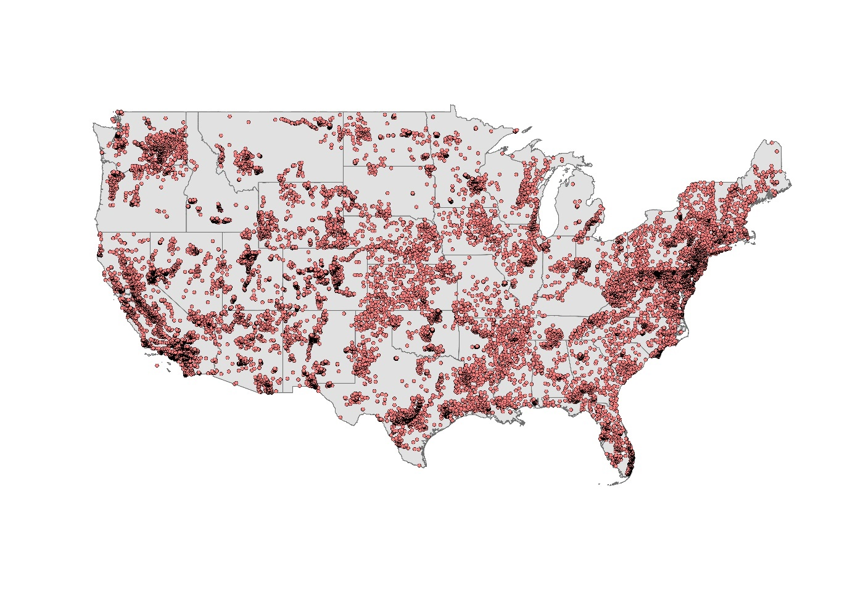
Fig. S 1 A total of 55,839 data from 26,175 sampling sites used for groundwater corrosivity assessment and modeling in the contiguous U.S.

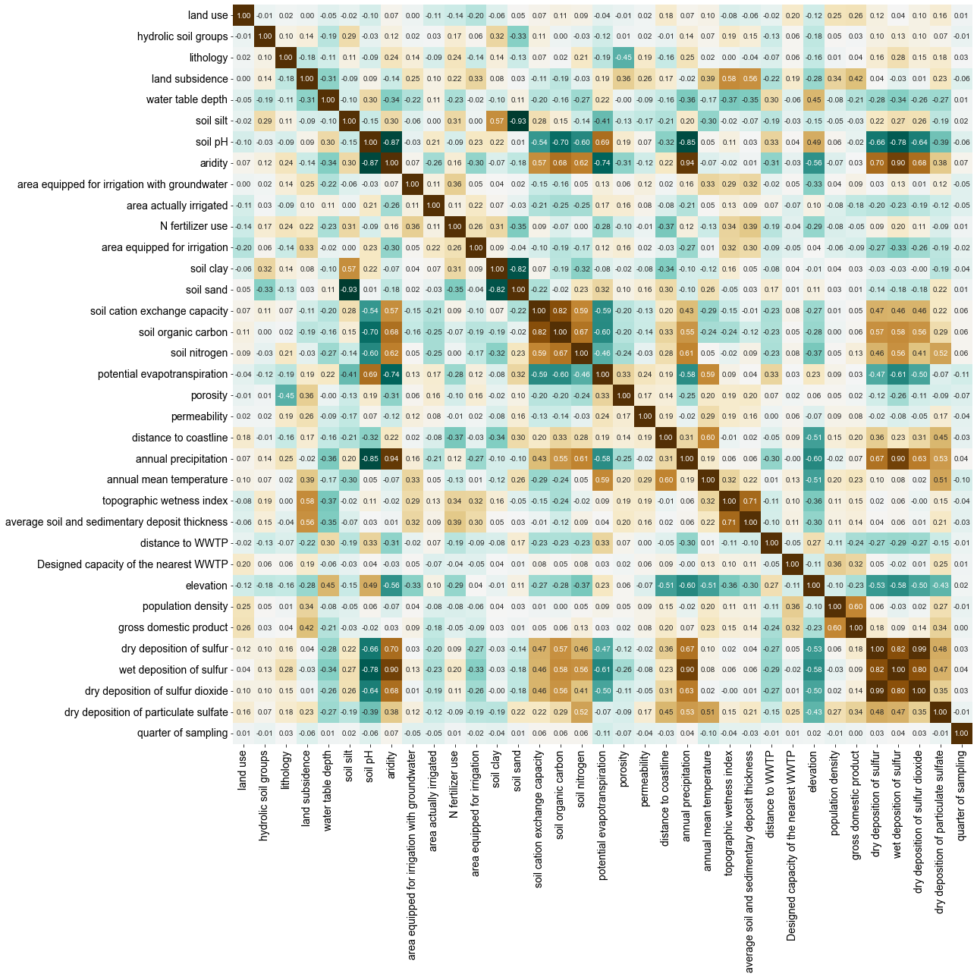
Fig. S 2 Pearson correlation heatmap of all potential variables.

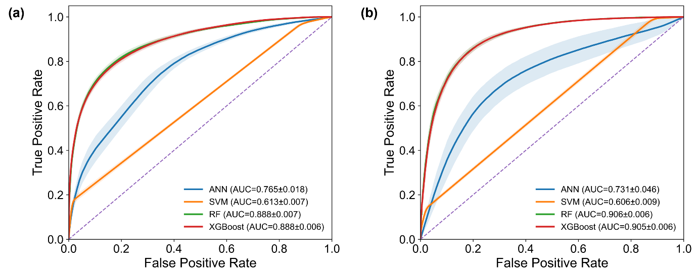
Fig. S 3 Comparison of ROC curves for four candidate models in predicting groundwater corrosivity. Receiver operating characteristic (ROC) curves comparing the four candidate classifiers (ANN, SVM, Random Forest, and XGBoost) for the (a) Fe corrosivity model and (b) Pb corrosivity model. ROC curves were generated from 100 repeated site-level 80/20 train–test splits. The mean ROC curve for each algorithm (solid line) was obtained by interpolating true positive rates onto a common false positive rate grid and averaging across splits. Shaded bands indicate ±1 standard deviation across splits.

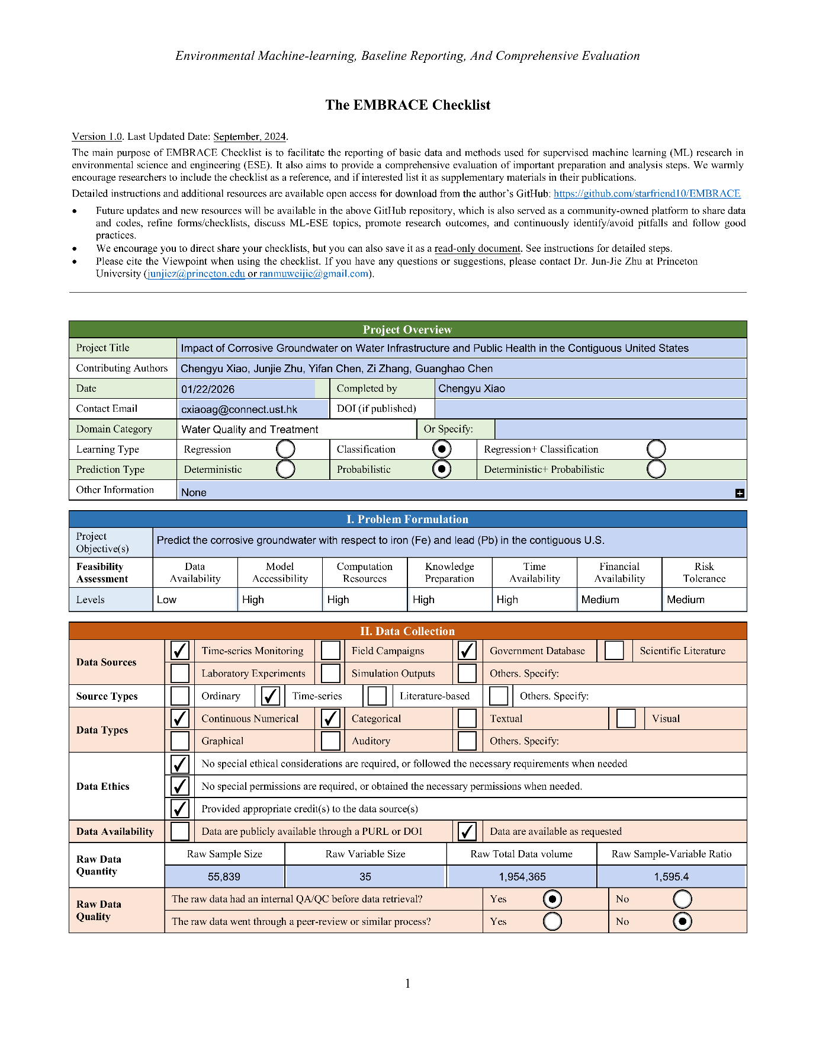
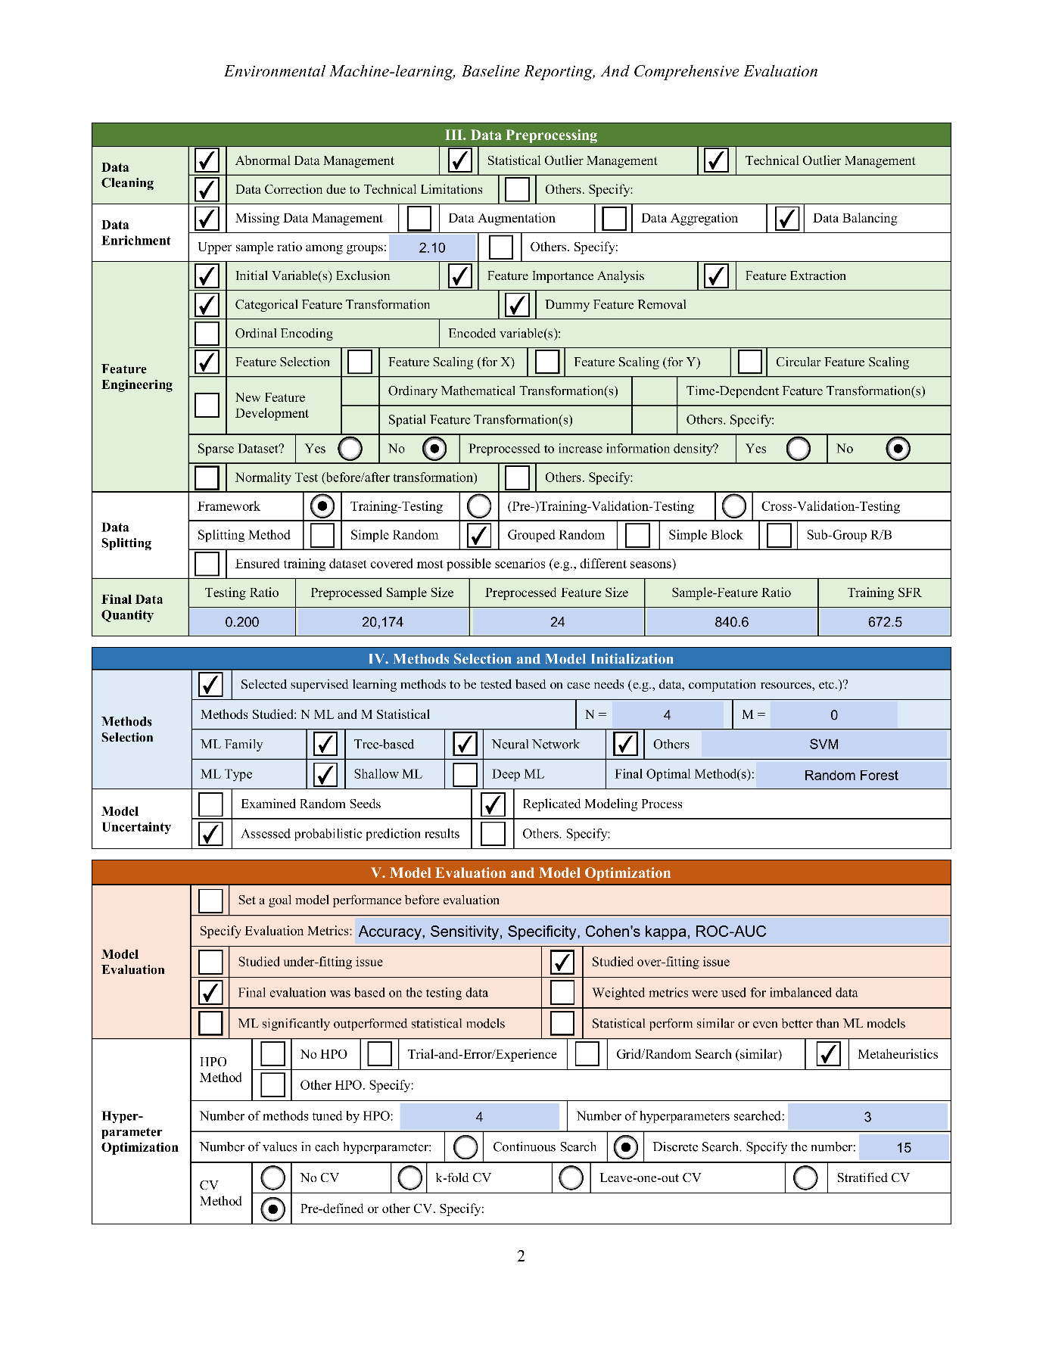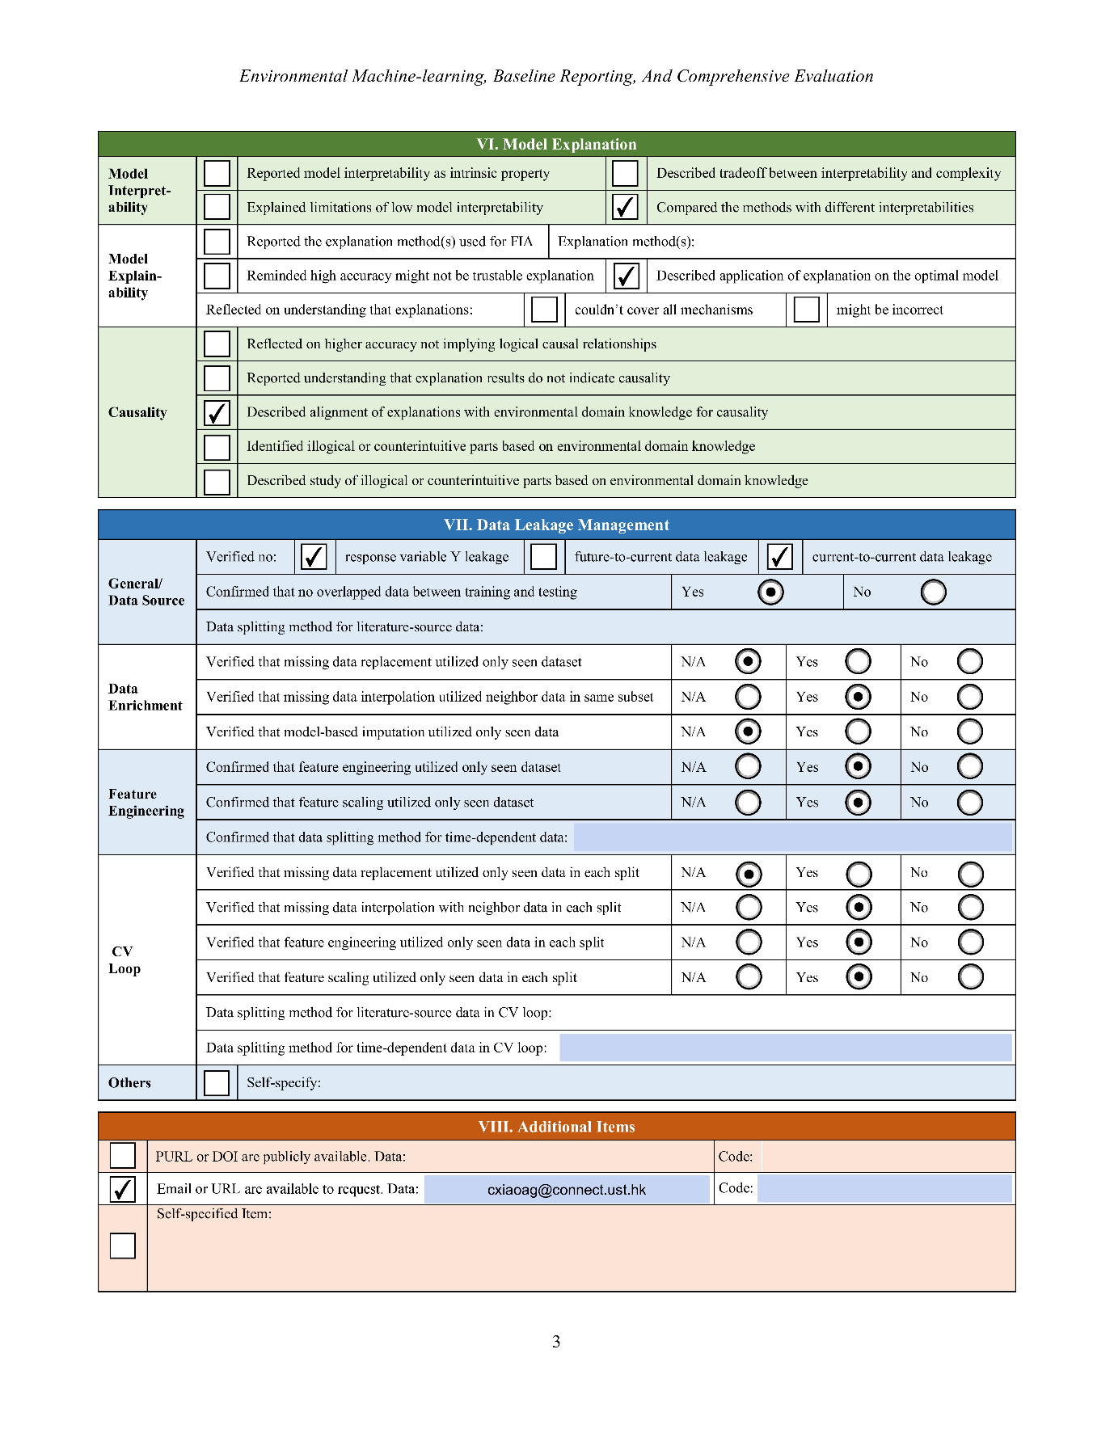
Fig. S 4 The EMBRACE Checklist results to improve the transparency of the built machine learning models (Fe corrosivity model shown as an example) (Zhu et al., 2023; Zhu et al., 2024).

Supplementary Results
Table S 12 Number of groundwater sites with measured data collected both before and after the year 2000 at each state (shown in descending order based on number of sites in each state).
Number | Name | Number of sites | GDP  (billion USD)(BEA, 2023) | Population (million)(Bureau, 2022) | Groundwater withdrawals (million gallons per day)(Dieter et al., 2018) | Groundwater withdrawals percentage(Dieter et al., 2018)
1 | California | 511 | 3233.15 | 39.03 | 17400 | 60.42%
2 | Texas | 155 | 2032.93 | 30.03 | 7200 | 33.80%
3 | Washington | 116 | 672.13 | 7.79 | 1530 | 35.92%
4 | Nevada | 105 | 192.22 | 3.18 | 1440 | 48.65%
5 | Arizona | 92 | 414.27 | 7.36 | 2760 | 46.15%
6 | Florida | 82 | 1279.12 | 22.24 | 3770 | 24.64%
7 | Minnesota | 81 | 383.62 | 5.72 | 776 | 24.02%
8 | Iowa | 75 | 200.44 | 3.2 | 630 | 23.42%
9 | New Jersey | 74 | 656.48 | 9.26 | 569 | 10.72%
10 | Michigan | 64 | 547.77 | 10.03 | 767 | 7.59%
11 | South Carolina | 61 | 259.93 | 5.28 | 365 | 5.92%
12 | Virginia | 60 | 590.8 | 8.68 | 298 | 4.43%
13 | Georgia | 54 | 661.11 | 10.91 | 1150 | 34.02%
14 | New Mexico | 53 | 105.46 | 2.11 | 1440 | 49.66%
15 | Utah | 53 | 219.18 | 3.38 | 1150 | 27.19%
16 | Colorado | 41 | 428.04 | 5.84 | 1530 | 14.85%
17 | Illinois | 39 | 875.57 | 12.58 | 891 | 8.49%
18 | Alabama | 33 | 241.75 | 5.07 | 501 | 6.07%
19 | Ohio | 32 | 698.22 | 11.76 | 866 | 13.28%
20 | Tennessee | 32 | 425.41 | 7.05 | 430 | 6.70%
21 | Oregon | 31 | 260.11 | 4.24 | 1480 | 22.49%
22 | North Carolina | 22 | 625.68 | 10.7 | 520 | 5.05%
23 | Massachusetts | 20 | 615.15 | 6.98 | 380 | 26.95%
24 | Indiana | 18 | 401.47 | 6.83 | 699 | 9.74%
25 | West Virginia | 17 | 80.14 | 1.78 | 134 | 5.78%
26 | Kansas | 16 | 182.35 | 2.94 | 2840 | 70.65%
27 | Pennsylvania | 16 | 789.5 | 12.97 | 628 | 10.40%
28 | Maryland | 13 | 421 | 6.16 | 295 | 4.52%
29 | New York | 12 | 1775.71 | 19.68 | 890 | 8.24%
30 | Maine | 10 | 73.78 | 1.34 | 84.8 | 16.66%
31 | Wisconsin | 9 | 336.46 | 5.89 | 772 | 13.40%
32 | Oklahoma | 6 | 201.66 | 4.02 | 1110 | 56.63%
33 | Idaho | 5 | 94.91 | 1.94 | 5350 | 30.23%
34 | Arkansas | 4 | 140.78 | 3.01 | 9590 | 69.49%
35 | Connecticut | 4 | 282.48 | 3.63 | 128 | 4.09%
36 | Mississippi | 3 | 114.95 | 2.94 | 2260 | 84.01%
37 | Missouri | 3 | 344.12 | 6.18 | 1740 | 20.64%
38 | North Dakota | 2 | 58.01 | 0.78 | 202 | 14.43%
39 | Louisiana | 1 | 238.2 | 4.59 | 1740 | 19.89%
40 | New Hampshire | 1 | 91.25 | 1.4 | 80.4 | 8.60%
41 | South Dakota | 1 | 56.31 | 0.91 | 238 | 59.50%
42 | Wyoming | 1 | 39.32 | 0.58 | 748 | 9.19%
43 | District of Columbia | 0 | 145.49 | 0.67 | 0 | 0.00%
44 | Delaware | 0 | 74.26 | 1.02 | 170 | 21.52%
45 | Kentucky | 0 | 225.23 | 4.51 | 207 | 7.31%
46 | Montana | 0 | 55.19 | 1.12 | 205 | 2.09%
47 | Nebraska | 0 | 144.18 | 1.97 | 5820 | 61.26%
48 | Rhode Island | 0 | 63.17 | 1.09 | 32.7 | 9.53%
49 | Vermont | 0 | 35.07 | 0.65 | 36.7 | 40.37%

Table S 13 Water infrastructure and population affected by highly corrosive groundwater in the contiguous U.S.
 |  | Corrosive Groundwater Utilization Scenario | Corrosive Groundwater Dominance Scenario
Water infrastructure | Total number of PWS | 44,207
 | Groundwater sourced PWS | 34,250
 | Estimated total pipes length in the contiguous US | 1,900,000 km
 | Corrosive groundwater affected pipe length (km) | 209,489 km  (205,742–213,725 km) | 108,729 km  (106,454–111,155 km)
 | Percentage of total pipes | 11.03% | 5.72%
Public health | Total population in contiguous U.S. (2022) (Bureau, 2022) | ~ 331.02 million
 | PWS served population | 292,988,430
 | Corrosive groundwater affected population | 7,787,736  (7,656,911–7,924,458) | 6,485,569  (6,358,202–6,618,072)
 | Percentage of total PWS served population | 2.66% | 2.21%
 | Percentage of total population in the contiguous U.S. | 2.35% | 1.96%
PWS: Public Water Systems.

Table S 14 State-level population served by PWS and number of PWS (Sorted in descending order by population served by PWS).
State | Population served by PWS | Total number of PWS | Population served by groundwater-sourced PWS | Number of groundwater-sourced PWS
CA | 39748079 | 2840 | 7587810 | 2075
TX | 29012004 | 4531 | 5621423 | 3290
FL | 20879350 | 1523 | 15899856 | 1438
IL | 12014107 | 1664 | 3186388 | 1080
PA | 11437755 | 1847 | 1498989 | 1434
OH | 10468255 | 1082 | 2805358 | 829
GA | 10207629 | 1581 | 1882201 | 1359
NC | 8984002 | 1887 | 1547179 | 1447
NJ | 8855932 | 561 | 2330497 | 403
WA | 7733214 | 2218 | 3171222 | 2015
MI | 7404528 | 1173 | 1758151 | 886
TN | 7299219 | 442 | 1656939 | 190
VA | 7179232 | 956 | 500366 | 681
AZ | 6840426 | 824 | 2951588 | 771
MA | 6788472 | 439 | 1740769 | 276
CO | 6656733 | 855 | 439733 | 513
AL | 5932941 | 494 | 1739853 | 284
MO | 5399633 | 1338 | 2072747 | 1127
NY | 5383990 | 1081 | 1549444 | 787
MD | 5364736 | 406 | 992165 | 356
LA | 5003898 | 863 | 3184008 | 786
IN | 4980599 | 756 | 2597306 | 653
MN | 4565969 | 942 | 3125798 | 900
KY | 4461492 | 362 | 387487 | 74
SC | 4167327 | 553 | 572777 | 334
WI | 4126766 | 984 | 2309434 | 929
OK | 3624001 | 880 | 574848 | 427
OR | 3549080 | 852 | 608811 | 635
UT | 3288928 | 487 | 900020 | 381
MS | 3101391 | 1002 | 2847532 | 989
NV | 3048457 | 202 | 267857 | 179
IA | 2942430 | 1037 | 1802191 | 908
AR | 2923759 | 675 | 791048 | 379
KS | 2837941 | 847 | 897312 | 508
CT | 2794951 | 472 | 251317 | 396
NM | 2045813 | 604 | 1111392 | 559
NE | 1578382 | 579 | 994927 | 559
WV | 1503165 | 408 | 296227 | 147
ID | 1443053 | 682 | 1131281 | 621
RI | 1033979 | 75 | 160522 | 51
DE | 1020525 | 199 | 563179 | 195
NH | 897100 | 688 | 336747 | 630
SD | 845342 | 429 | 361282 | 282
ND | 721568 | 306 | 349518 | 218
MT | 712193 | 626 | 319627 | 542
ME | 686217 | 332 | 227882 | 283
DC | 665214 | 4 | 0 | 0
VT | 445607 | 363 | 176148 | 286
WY | 383046 | 232 | 80990 | 158
PWS: Public Water Systems.

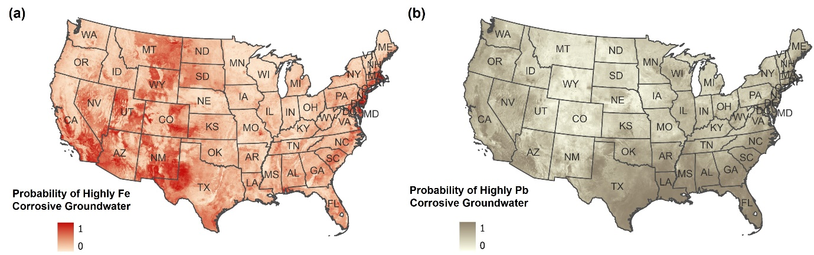
Fig. S 5 Probability of (a) highly Fe corrosive and (b) highly Pb corrosive groundwater at 1-km resolution in the contiguous U.S.

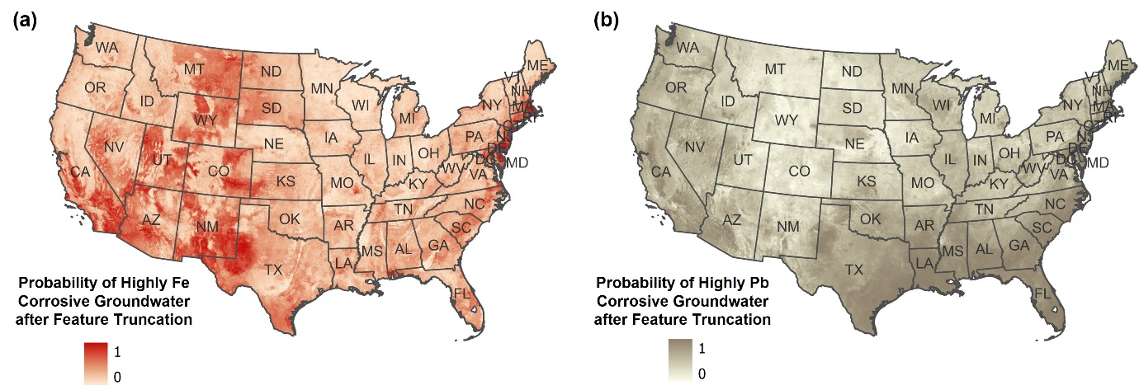
Fig. S 6 Maps of predicted results of groundwater corrosivity for (a) Fe and (b) Pb in the contiguous U.S. generated using truncated features to the upper or lower limit of the training dataset. In comparison to the predictions made with original feature values, as shown in Fig. S5, the differences in the probabilities of Fe and Pb corrosivity per square kilometer across the contiguous U.S. were found to range from -1.11 × 10¹⁶ to 1.11 × 10¹⁶. A Student’s T-test was performed, yielding p-values of 0.99 for Fe corrosivity and 1 for Pb corrosivity, indicating no statistically significant differences between the predictions from the two datasets. This implies that although the feature range in the contiguous U.S. surpassed that of the training dataset, its influence on the predicted groundwater corrosivity was negligible.

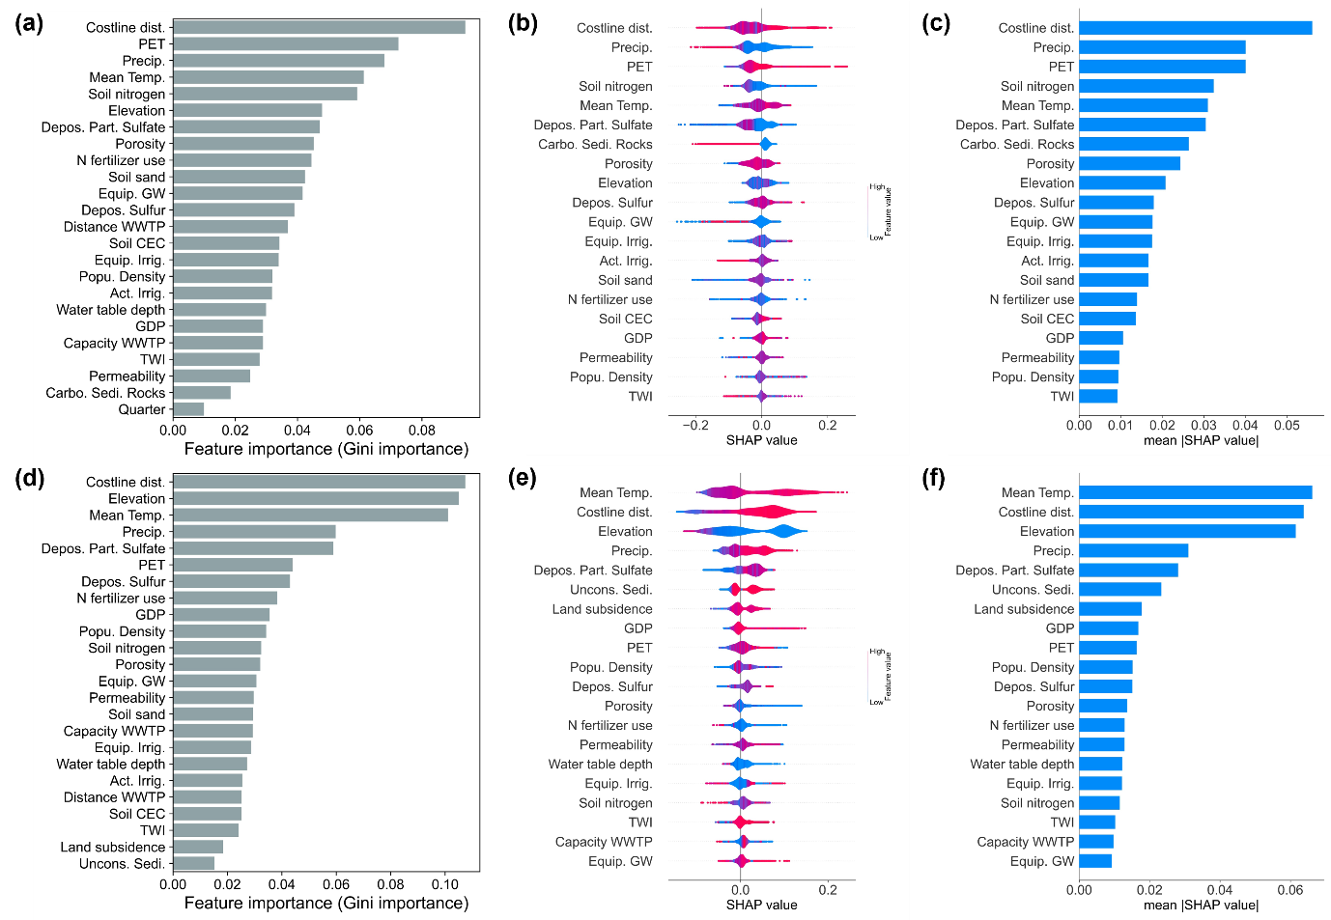
Fig. S 7 Feature importance and SHAP interpretation for groundwater corrosivity models. (a)–(c) summarize predictor importance for the Fe corrosivity model, and (d)–(f) are results of the Pb corrosivity model. (a) and (d) show Random Forest impurity-based feature importance. (b) and (e) show SHAP summary plots, where each point represents one sample and color indicates the feature value (blue = low, red = high); positive SHAP values increase the predicted probability of highly corrosive groundwater, while negative values decrease it. (c) and (f) show the mean absolute SHAP value (mean |SHAP|), ranking predictors by their average contribution magnitude across samples.

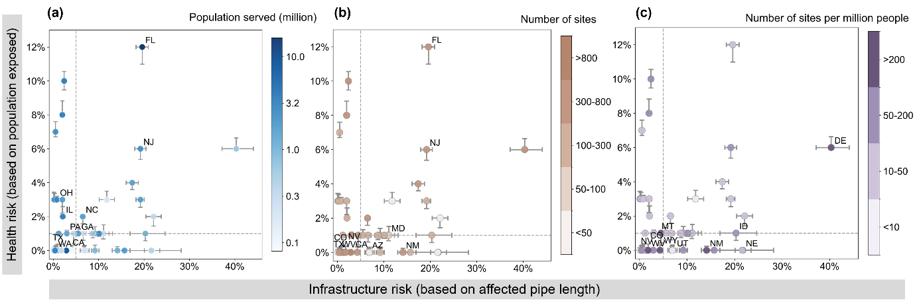
Fig. S 8 State-level infrastructure and health risks under the Corrosive Groundwater Dominance Scenario, with point colors indicating state-level (a) population served by public water systems; (b) number of monitoring sites; and (c) number of monitoring sites per million people. The Corrosive Groundwater Dominance Scenario includes only water supply systems in which highly corrosive groundwater accounts for at least 50% of observations within the service area. Infrastructure risk is defined as the percentage of total pipe length affected by iron corrosion, while health risk represents the percentage of the population potentially exposed to lead contamination. For each state, the central marker denotes the median risk estimate, and horizontal and vertical error bars indicate the 5th–95th percentile uncertainty range derived from Monte Carlo simulations accounting for variability in pipe length per capita and material composition. Dashed vertical and horizontal lines denote the national medians of infrastructure and health risks, respectively. State labels are shown for the top 10 states ranked by the variable represented by point color (from highest to lowest) across all states. Results for the Corrosive Groundwater Utilization Scenario are illustrated in Fig. 6.

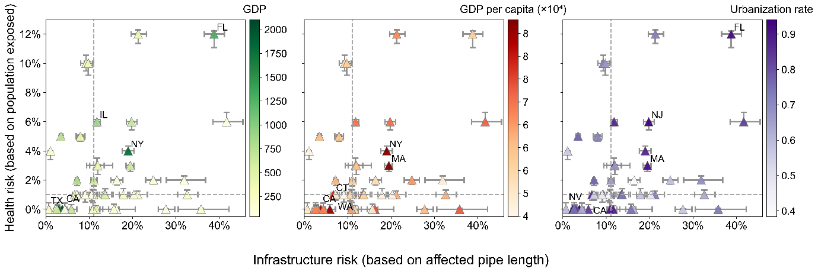
Fig. S 9 State-level infrastructure and health risks in relation to socioeconomic factors (gross domestic product (GDP), GDP per capita, and Urbanization rate) under the Corrosive Groundwater Utilization Scenario. The Corrosive Groundwater Utilization Scenario includes only water supply systems whose service areas contain any highly corrosive groundwater. For each state, the central marker denotes the median risk estimate, and horizontal and vertical error bars indicate the 5th–95th percentile uncertainty range derived from Monte Carlo simulations accounting for variability in pipe length per capita and material composition. Dashed vertical and horizontal lines indicate the national medians of infrastructure and health risks, respectively. States labeled correspond to the five states with the highest values of the socioeconomic indicator shown in that panel.

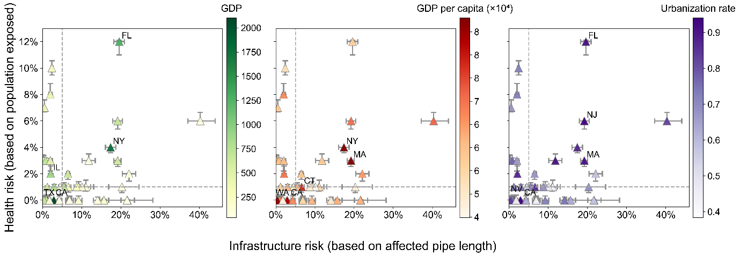
Fig. S 10 State-level infrastructure and health risks in relation to socioeconomic factors (gross domestic product (GDP), GDP per capita, and Urbanization rate) under the Corrosive Groundwater Dominance Scenario. The Corrosive Groundwater Dominance Scenario includes only water supply systems in which highly corrosive groundwater accounts for at least 50% of observations within the service area. For each state, the central marker denotes the median risk estimate, and horizontal and vertical error bars indicate the 5th–95th percentile uncertainty range derived from Monte Carlo simulations accounting for variability in pipe length per capita and material composition. Dashed vertical and horizontal lines indicate the national medians of infrastructure and health risks, respectively. States labeled correspond to the five states with the highest values of the socioeconomic indicator shown in that panel.

References
BEA 2023. Gross domestic product of the United States in 2023, by state (in billion current U.S. dollars). Statista.
Bureau, U.C. 2022. Resident population of the U.S. in 2022, by state (including the District of Columbia) (in millions).
Bureau, U.S.C. 2023. Population Estimate for 2023.
Chen, J., Gao, M., Cheng, S., Hou, W., Song, M., Liu, X. and Liu, Y. 2022. Global 1 km× 1 km gridded revised real gross domestic product and electricity consumption during 1992–2019 based on calibrated nighttime light data. Scientific Data 9(1), 202.
Dieter, C.A., Maupin, M.A., Caldwell, R.R., Harris, M.A., Ivahnenko, T.I., Lovelace, J.K., Barber, N.L. and Linsey, K.S. (2018) Estimated use of water in the United States in 2015, US Geological Survey.
Ehalt Macedo, H., Lehner, B., Nicell, J., Grill, G., Li, J., Limtong, A. and Shakya, R. 2022. Distribution and characteristics of wastewater treatment plants within the global river network. Earth System Science Data 14(2), 559-577.
EPA, U.S. 2023. 7th Drinking Water Infrastructure Needs Survey and Assessment.
Fan, Y., Li, H. and Miguez-Macho, G. 2013. Global patterns of groundwater table depth. Science 339(6122), 940-943.
Fick, S.E. and Hijmans, R.J. 2017. WorldClim 2: new 1‐km spatial resolution climate surfaces for global land areas. International journal of climatology 37(12), 4302-4315.
Fienen, M.N., Nolan, B.T. and Feinstein, D.T. 2016. Evaluating the sources of water to wells: Three techniques for metamodeling of a groundwater flow model. Environmental Modelling & Software 77, 95-107.
Folkman, S. 2018. Water main break rates in the USA and Canada: A comprehensive study.
Gao, J. 2020. Global 1-km downscaled population base year and projection grids based on the shared socioeconomic pathways, revision 01. NASA Socioeconomic Data and Applications Center (SEDAC).
Gleeson, T., Moosdorf, N., Hartmann, J. and van Beek, L.v. 2014. A glimpse beneath earth's surface: GLobal HYdrogeology MaPS (GLHYMPS) of permeability and porosity. Geophysical Research Letters 41(11), 3891-3898.
Group, N.s.O.B.P. 2009. Distance to the Nearest Coast, NASA Ocean Biology Distributed Active Archive Center.
Hartmann, J. and Moosdorf, N. 2012. The new global lithological map database GLiM: A representation of rock properties at the Earth surface. Geochemistry, Geophysics, Geosystems 13(12).
Hengl., T. 2018. Global DEM derivatives at 250 m, 1 km and 2 km based on the MERIT DEM (1.0) [Data set]. Zenodo.
Herrera-García, G., Ezquerro, P., Tomás, R., Béjar-Pizarro, M., López-Vinielles, J., Rossi, M., Mateos, R.M., Carreón-Freyre, D., Lambert, J. and Teatini, P. 2021. Mapping the global threat of land subsidence. Science 371(6524), 34-36.
More, K.S. and Wolkersdorfer, C. 2023. Exploring Advanced Statistical Data Analysis Techniques for Interpolating Missing Observations and Detecting Anomalies in Mining Influenced Water Data. ACS ES&T Water.
Poggio, L., De Sousa, L.M., Batjes, N.H., Heuvelink, G., Kempen, B., Ribeiro, E. and Rossiter, D. 2021. SoilGrids 2.0: producing soil information for the globe with quantified spatial uncertainty. Soil 7(1), 217-240.
Potter, P., Ramankutty, N., Bennett, E. and Donner, S. 2011. Global fertilizer and manure, version 1: nitrogen fertilizer application. Palisades, NY: NASA Socioeconomic Data and Applications Center (SEDAC).
Program, N.A.D. 2023. Total Deposition Maps, version 2023.01.
Siebert, S., Henrich, V., Frenken, K. and Burke, J. 2013. Update of the digital global map of irrigation areas to version 5. Rheinische Friedrich-Wilhelms-Universität, Bonn, Germany and Food and Agriculture Organization of the United Nations, Rome, Italy 10(2.1), 2660-6728.
Survey, U.S.G. 2016. National Water Information System data available on the World Wide Web (USGS Water Data for the Nation).
United States Department of the Interior, U.S.G.S., National Atlas of the United States 2007. North America Elevation 1-Kilometer Resolution.
Xiao, C., Qu, S., Ren, Z.J., Chen, Y., Zou, X., Chen, G. and Zhang, Z. 2024. Understanding the Global Distribution of Groundwater Sulfate and Assessing Population at Risk. Environmental Science & Technology.
Zhu, J.-J., Yang, M. and Ren, Z.J. 2023. Machine learning in environmental research: common pitfalls and best practices. Environmental Science & Technology 57(46), 17671-17689.
Zhu, J.J., Boehm, A.B. and Ren, Z.J. 2024. Environmental Machine Learning, Baseline Reporting, and Comprehensive Evaluation: The EMBRACE Checklist. Environ Sci Technol 58(45), 19909-19912.

